How to make BBQ Chicken Wraps:
- Add chicken, cheese, onion, cilantro(Koriander) and BBQ sauce to a mixing bowl and toss to combine. Add more BBQ sauce if needed, to taste.
- Layer tortillas with a ½ cup of the mixture. Starting at that end, roll the tortilla up, folding in the sides like a burrito.
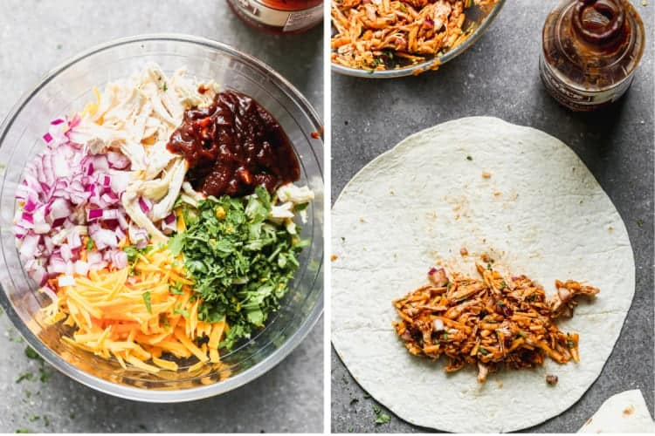
- Heat a skillet (koekenpan) over medium high-heat. Add enough oil to lightly coat the bottom of the pan (or spray generously with cooking spray) and once the oil is hot, place the wraps seam side down in the skillet.
- Cook, turning the wraps every minute or two, until they are golden and crispy on all sides and warmed through. Serve immediately.

